The basic terminology and rules of Sudoku.

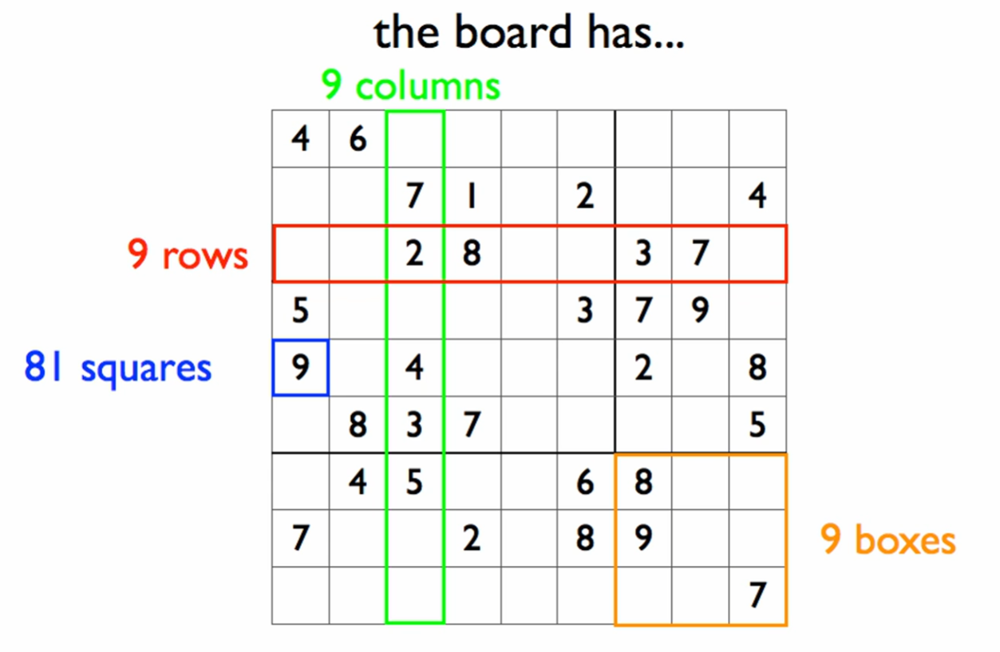

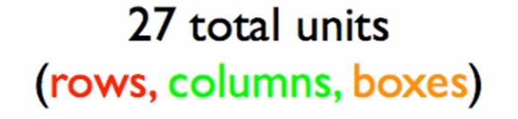

The goal: fill every square with Natural [1,9] WITHOUT DUPLICATION in any unit (row, column, box)